**Geography 150 Lab 2: Part 1: Comparing cities and controls on temperature patterns.**

Monthly temperature and precipitation patterns for several US and world cities are provided below. Latitude and longitude, elevations for selected cities (Los Angeles, Yuma, Denver, St. Louis, Chicago, and Sitka), and a location on a small map are given. Answer the questions that follow by comparing the temperature charts, noting locations, and considering latitude, land and water contrasts, altitudes, and potentially the effects of wind or air masses (if known). *Note that locations at a similar latitude will have the same sun angles and day lengths through the year*. *Several charts are included for comparisons of temperature profiles.*

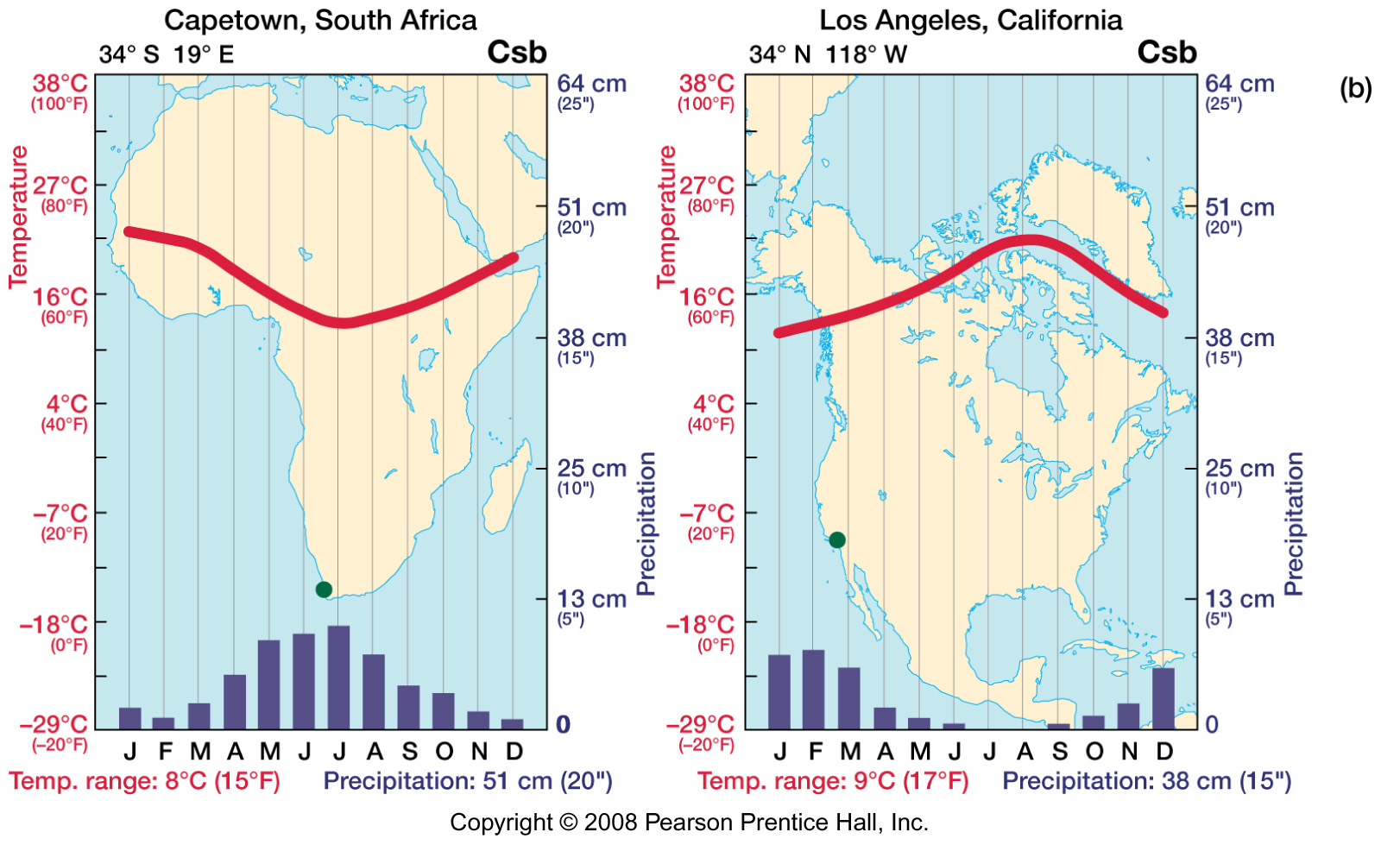

Los Angeles, CA: Elevation 285 feet (87 meters) average

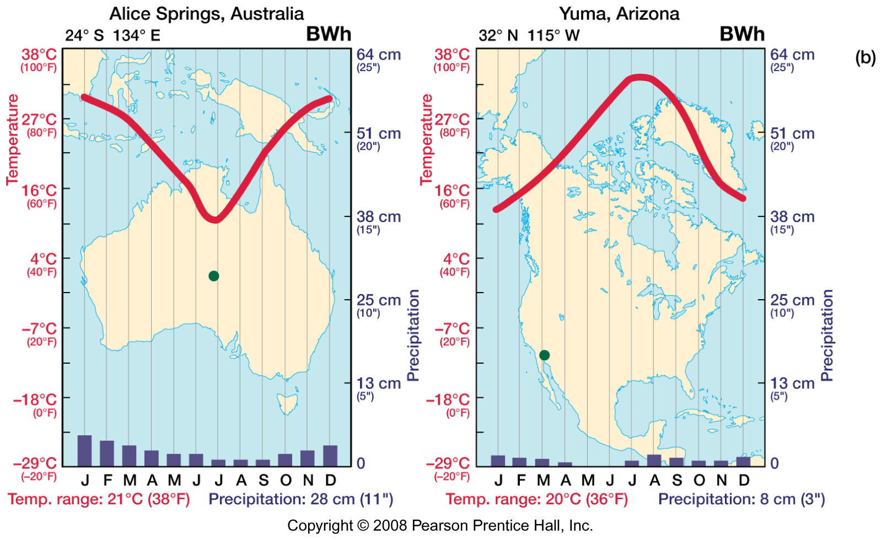

Yuma, AZ: Elevation 141 feet (42 meters)

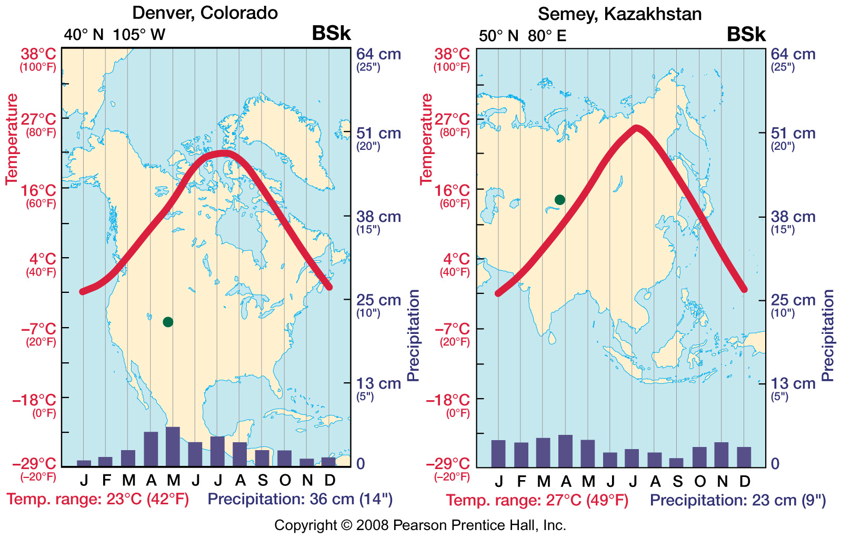

Denver, CO: Elevation 5280 feet (1609 meters)

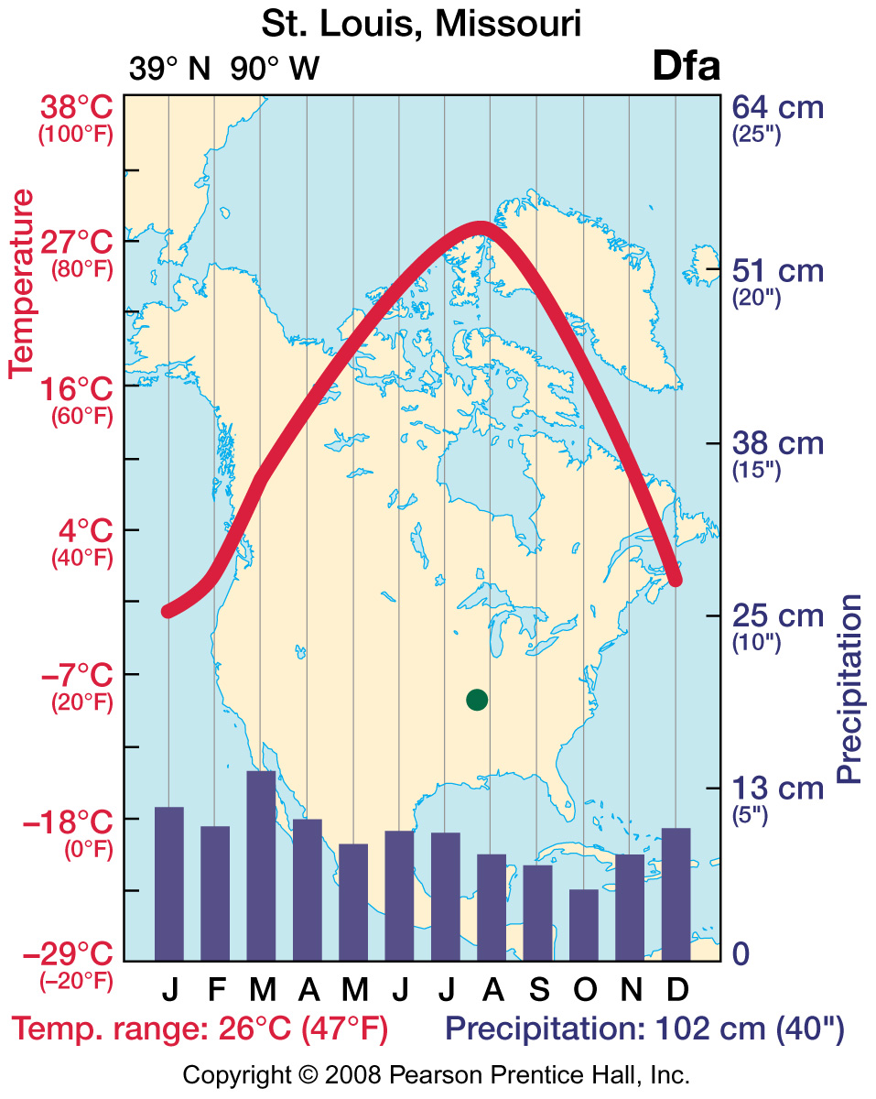

St. Louis, MO: Elevation 535 feet (133 meters)

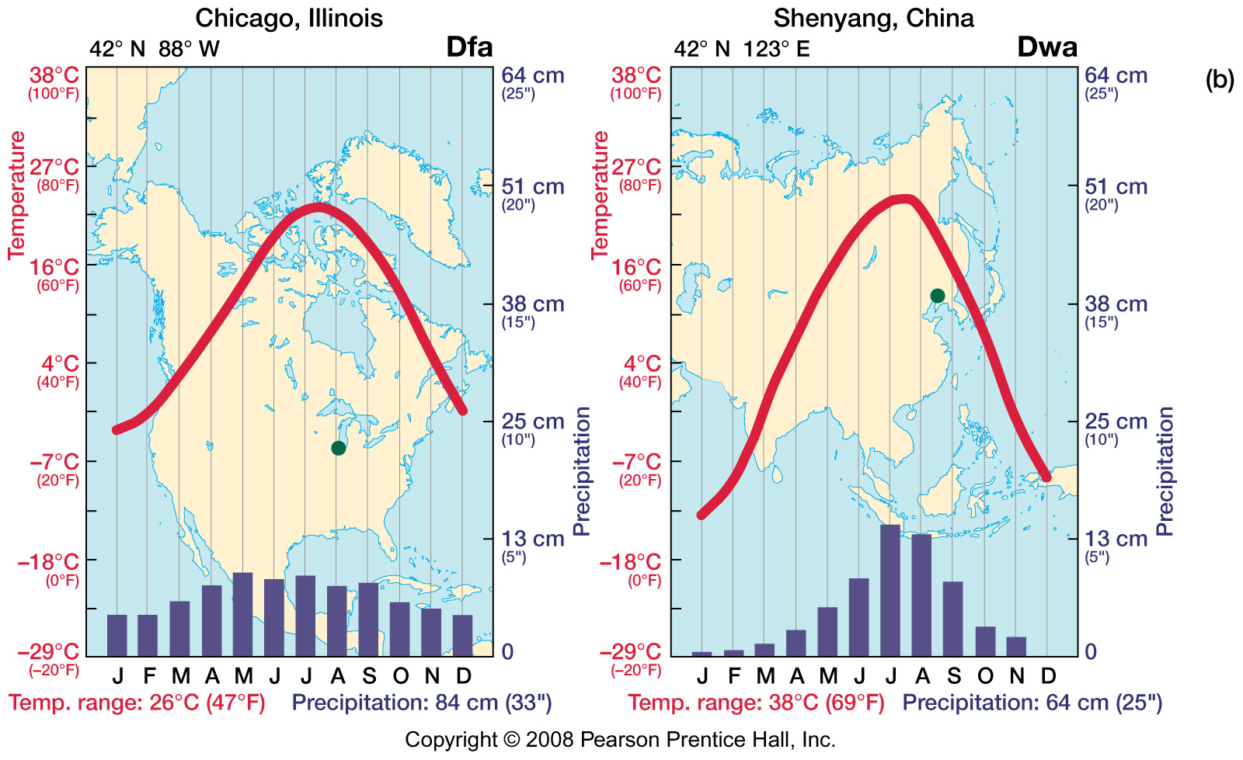

Chicago, Il: Elevation 594 feet (181 meters)

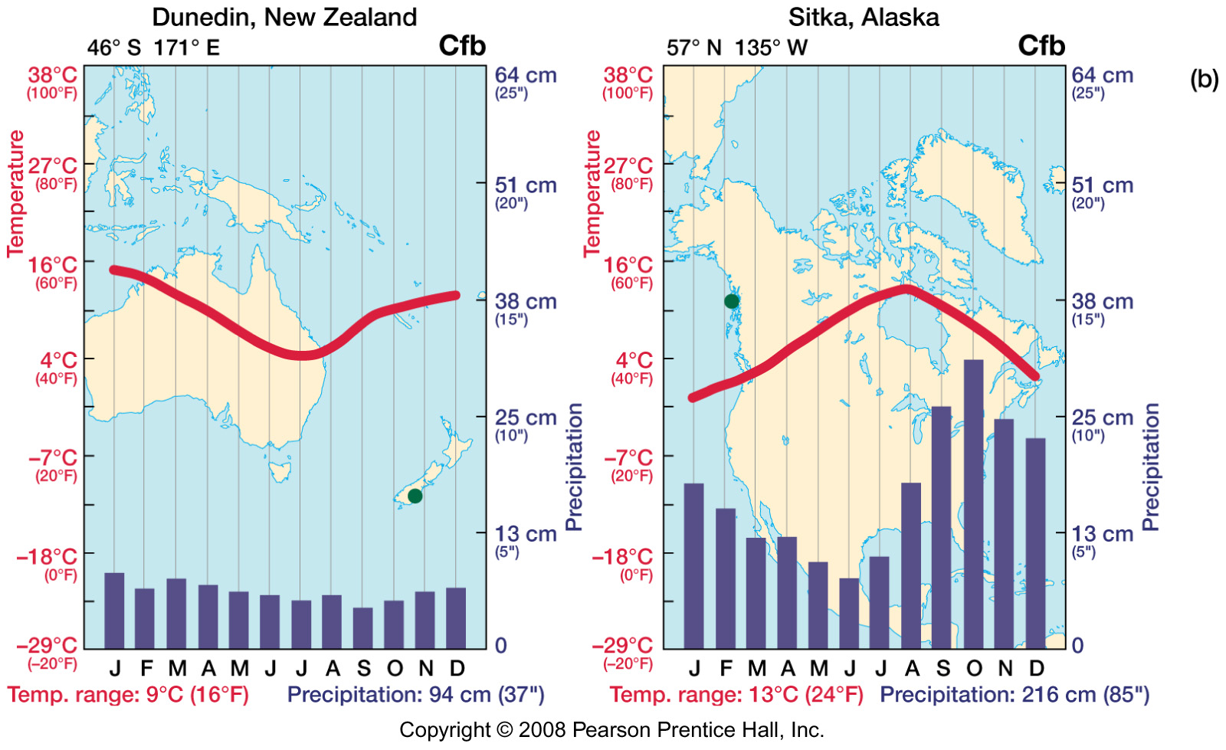

Sitka, AK: Elevation 26 feet (8 meters)

1. Why does Yuma, AZ have warmer summers than Los Angeles, CA?
2. Why does St. Louis, MO have warmer summers than Denver, CO?
3. When compared to Sitka, AK, Chicago, Il has colder winters. Why? Note the latitude of each.
4. Why does Sitka have a smaller range of temperatures through the year than Chicago?
5. Note the latitudes of Los Angeles, CA and Capetown, S. Africa. Explain the temperature profiles of each city and how they compare.
6. Other pairings (above) are made for comparisons of climates of selected cities. Note that Chicago and Shenyang share the same latitude. Would you expect Sitka, AK and Dunedin, New Zealand to have similar ranges of temperature? Which of these two cities is at a higher latitude? Which of these two cities reaches cooler temperatures through the year?

**Part 2: Using world maps of isotherms (lines of equal temperature) and a map of shallow ocean currents to examine climate and temperature patterns.**

The following questions are based on the figures (maps below) of average January sea level temperatures and average July sea level temperatures globally.

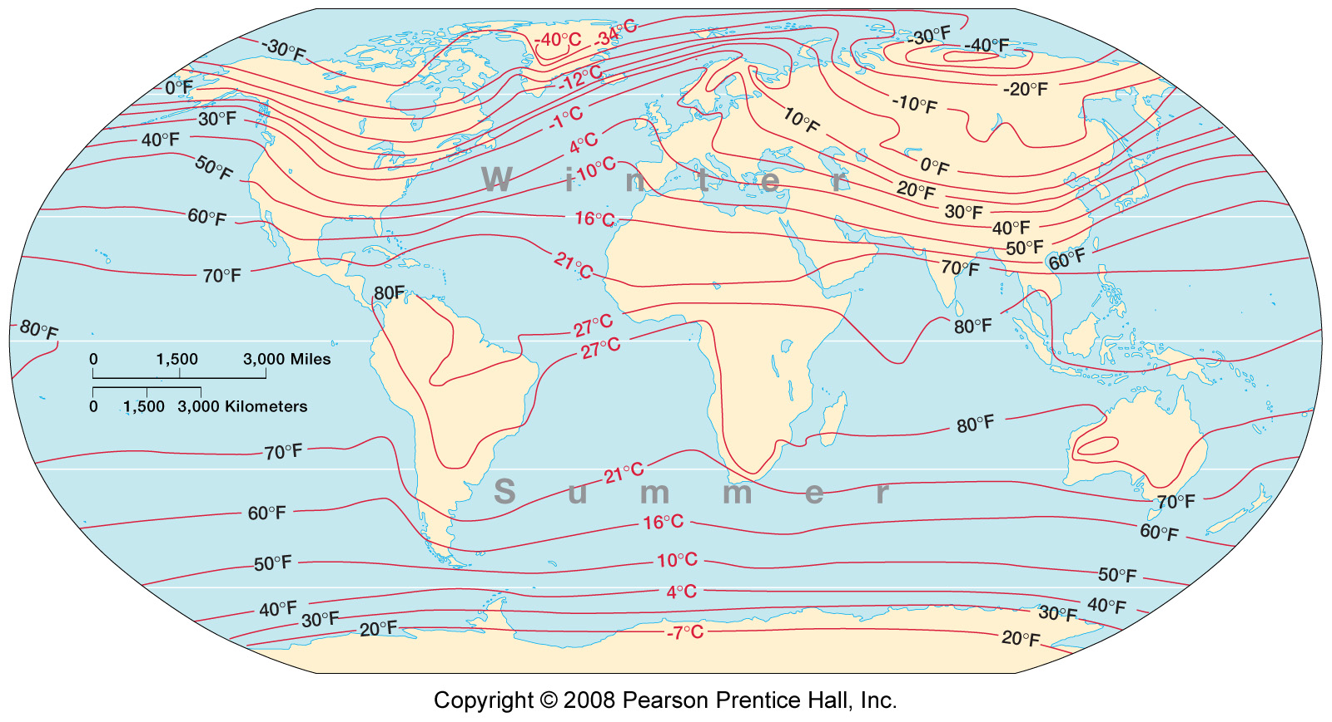

Figure 1: Average January sea level temperatures

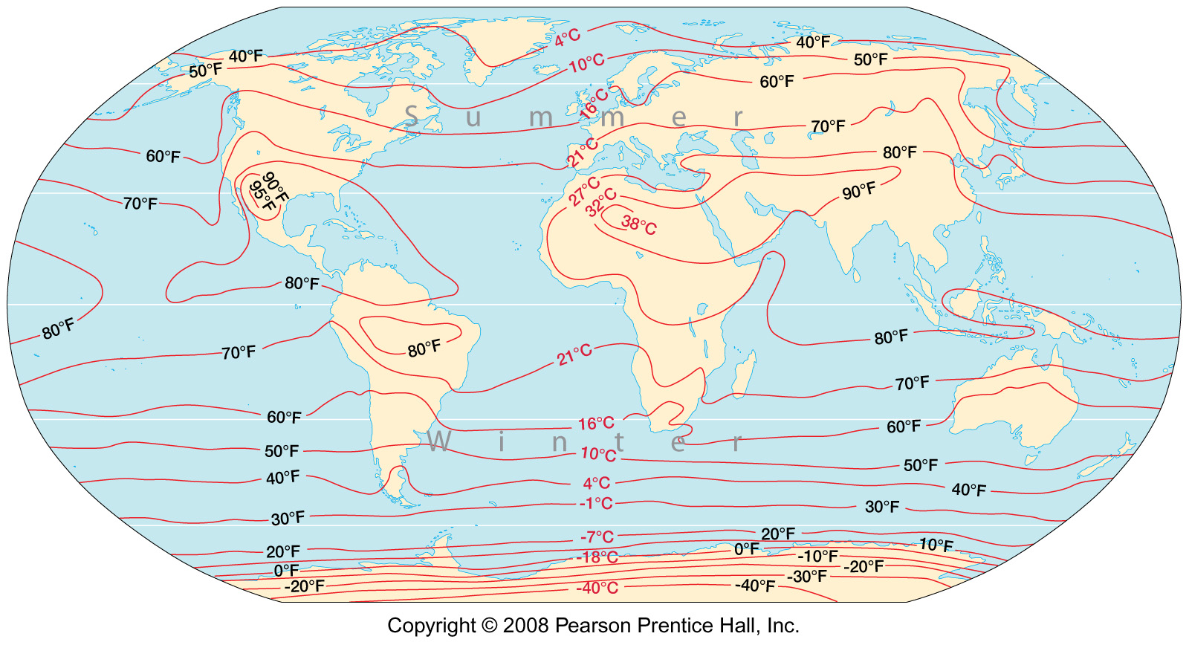

Figure 2: Average July sea level temperatures

Note also a reference map of the oceanic gyres; the large patterns of shallow ocean currents, driven by the Coriolis effect (below). The north Pacific gyre circulates in a clockwise direction, bring warmer ocean water northward in the western Pacific (Kuroshio current on map) and cooler ocean water southward along our coast (California current on map). Coastal area climates and temperatures will be influenced by water temperatures in the adjacent ocean through the year. For example, the Gulf stream in the western north Atlantic provides comfortable swimming temperatures in Virginia or the Carolinas during the warmer seasons, while ocean swimming will be in very brisk water throughout the year as far south as Baja, Mexico on our coast.

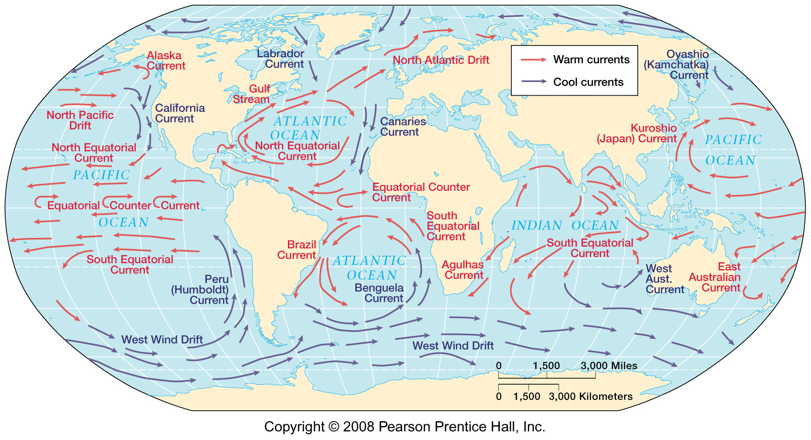

*Using figures 1 and 2:*

1. Is the temperature contrast between the equator and the Arctic region greatest in winter or summer?
2. Were latitude the only control on temperature, the isotherms would run straight across the maps from east to west. Describe an area of the earth where you can observe this pattern with the isotherms. Why is the pattern seen here?
3. Is the influence of cool ocean currents on coastal temperatures more pronounced in summer or winter? Why?
4. Comparing the January map with the July map, describe one region of the world that exhibits a large annual temperature range (the difference between the January and July average temperatures).

What explains the large annual temperature range?

1. Describe one region of the world that exhibits a small annual temperature range. What explains this small annual temperature range.
2. Consider you are to draw a line straight across the July temperature map, starting where the 60 degree Fahrenheit isotherm (16 degree Celsius) reaches the left edge of the map (west of our region in the Pacific Ocean) and ending where that same 60 degree Fahrenheit (16 degrees C) isotherm reaches the right edge of the map. A hypothetical horizontal straight line isotherm pattern would imply no land-water contrasts, ocean currents, and so on.

Compare the 60 degrees Fahrenheit (16 degrees C) isotherm on the map with your hypothetical straight line. In places where the actual 16 degrees C is south of the hypothetical line, temperatures are lower than expected. In places where the actual 16 degrees C isotherm is north of the hypothetical line, temperatures are higher than expected.

As you move along the line across the map from west to east, explain the specific deviations of the 16 degrees C isotherm from the hypothetical straight line.